FF. AUG 7TH

FS. AUG 24TH

1. EVIDENCE FOR 3D MODELLING (3D OBJECT/SCENE)

* Which design elements am I focusing on? The design elements I am focusing on is Colour Size and Shapes.
* Which tool/tools am I using? I will be using Blender to create my object. Blender is a 3D modelling software you can download from the internet. I will also be using Tilt Brush as another 3D drawing software.
* What techniques (eg. snapshots of tools from Blender) In blender I used the duplicate, scale, join and extrude techniques and tools to create my model.
* How am I testing? I tested my model using the VR headset as I experienced my model through VR. I also uploaded it to Sketchfab which allowed me to interact with it through Sketchfab and my website.
* Is this object fit for purpose? How do I know (hint: what are the specifications for the 3D object?)­­ It is fit for purpose as it embraces the design elements and meets the specifications. I believe that my 3D object is fit for purpose as it is of near professional quality, it doesn’t use any premade objects in it and it is displayed on my website.
* How do you embed the 3D object in HTML?? Once I uploaded my object to Sketchfab there was an embed option on Sketchfab which I could copy and paste in to my HTML code to display on my website.
* Any Legal/Ethical/Moral issues that I need to think about/research? I have used images off the internet however I linked them to the original pages that they came from. I also used some other models from Michael and Ben who are in my class but I did get permission to use their object and acknowledge that it is theirs. I have also used the google font Source Sans Pro that I acquired from the google fonts website and put into my website. I uploaded my model to Sketchfab this means people have access to my model and can take it off Sketchfab if they want. I am aware of this and am fully responsible for my model. In Sketchfab I have put a Creative Commons licence on my model this allows others can distribute, remix, tweak and build upon my work as long as they credit me. My model also meets the terms and conditions of Sketchfab. I copied code from W3 schools and have acknowledged their code in my code. I copied and edited code for my navbar and image slideshow. I have uploaded my website to Github. This allows me and others to access my website online rather than having to access it through my laptop. I am aware that anyone will have access to my github repository provided they have the correct link. I know that I am responsible for my website whilst it is on github and aware that github will not be liable for any damages or losses arising from my use or inability to the service. I created a colour pallet through the website coolors. I did not create an account through coolors so they do not have any record of my colour pallet and do not hold it. I have acknowledged that I acquired the colour pallet from coolors and am fully responsible for my colour pallet.

Images and links:

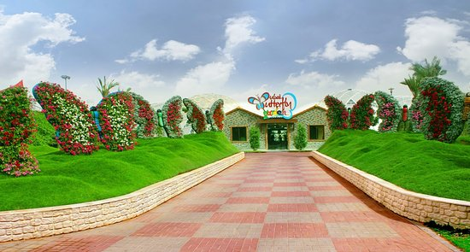

https://www.google.co.nz/url?sa=i&source=images&cd=&cad=rja&uact=8&ved=2ahUKEwiHs8DcnevcAhUWM94KHQLVADsQjRx6BAgBEAU&url=https%3A%2F%2Fwww.tripadvisor.com%2FAttraction_Review-g295424-d8467864-Reviews-Dubai_Butterfly_Garden-Dubai_Emirate_of_Dubai.html&psig=AOvVaw35luBkaGg9rylqwOMs82Gv&ust=1534290941200353

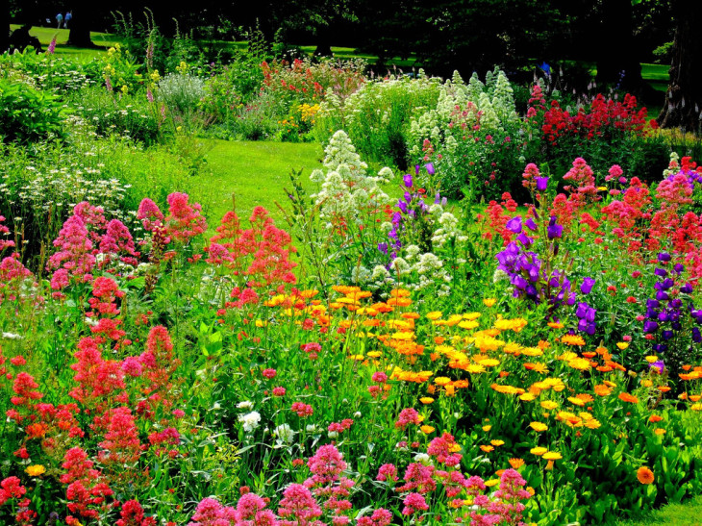

<https://techcrunch.com/2018/04/10/a-new-app-called-garden-helps-you-stay-in-touch-with-friends-and-family-without-facebook/>

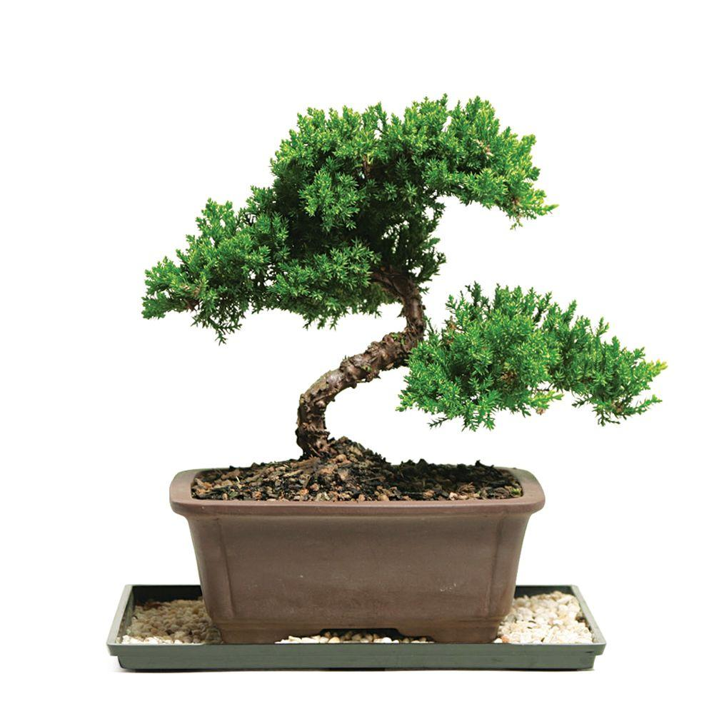

<https://www.homedepot.com/p/Brussel-s-Bonsai-Green-Mound-Juniper-Bonsai-Outdoor-DT-7079GMJ/100651255>

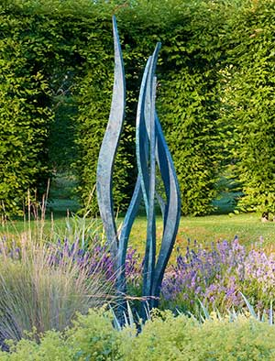

<https://www.davidharber.co.uk/sculpture.htm>

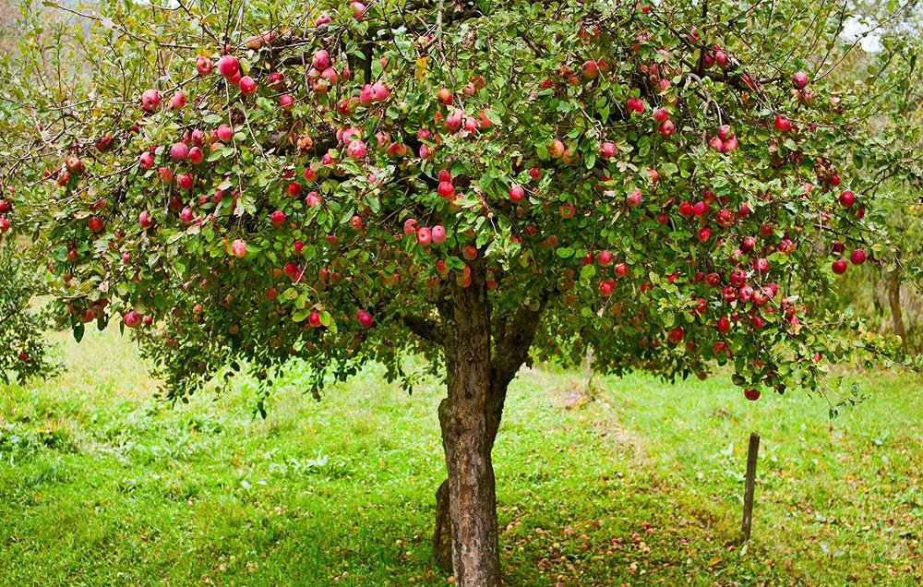

https://www.123rf.com/photo_7999347_apple-trees-in-an-orchard-with-red-apples-ready-for-harvest.html

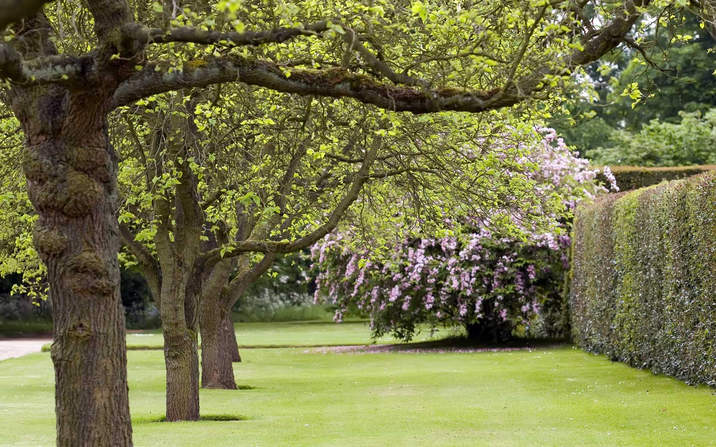

<http://homecaprice.com/exteriordesign/garden-trees-for-hot-climate/>

SNAPSHOTS OF 3D OBJECT BEING BUILT

|  |
| --- |
|  |

1. EVIDENCE OF DESIGNING YOUR WEBSITE

* Create wireframes (blueprints of layout) for each of your pages (3+)

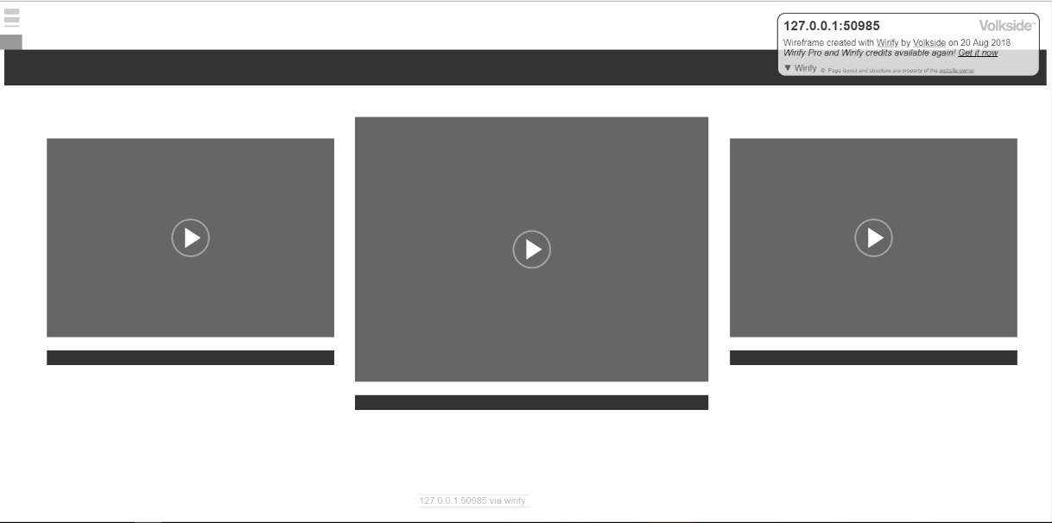

Home page Wireframe

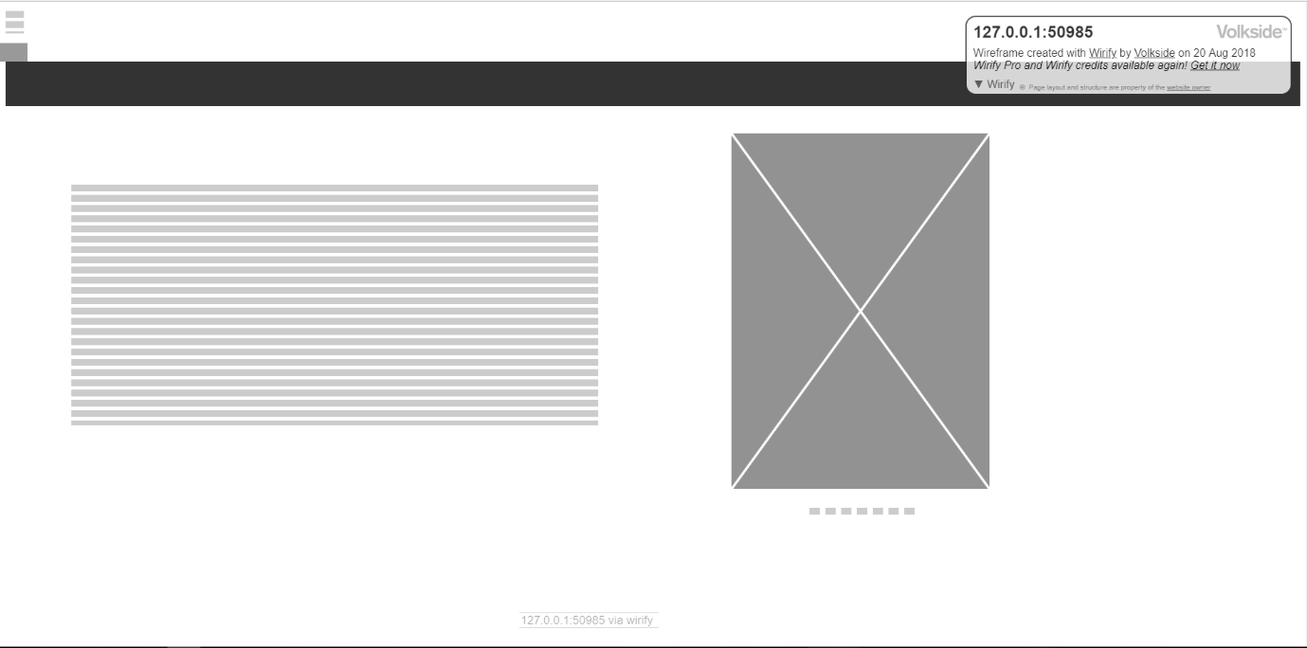

Development Process Wireframe

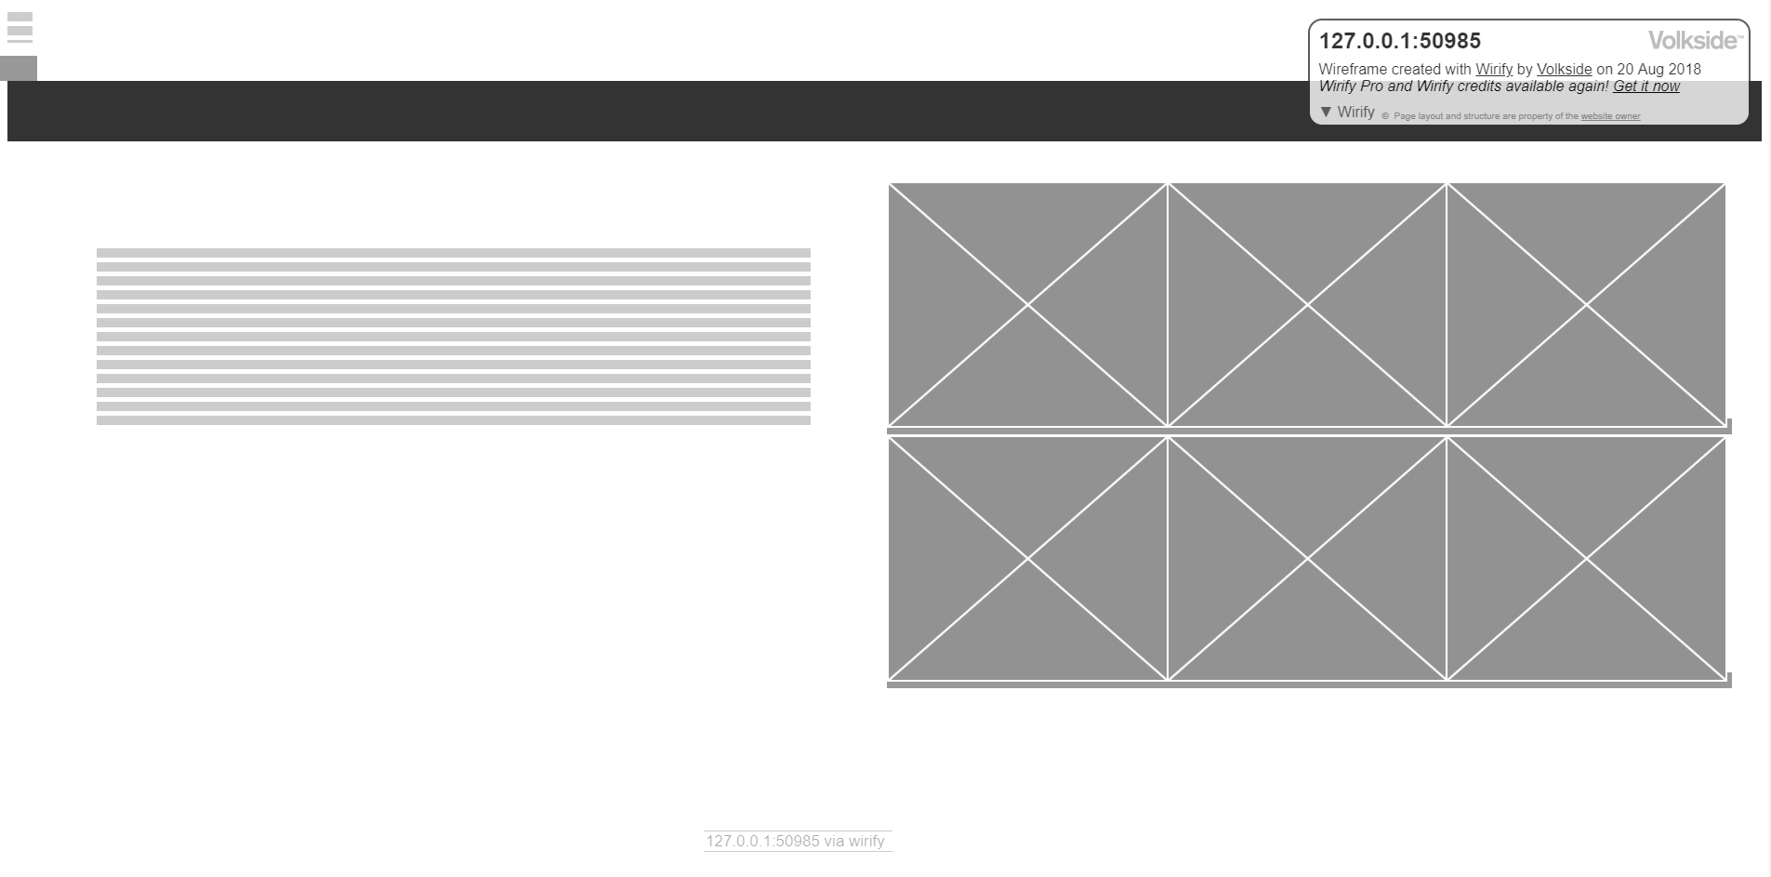

Inspiration Wireframe

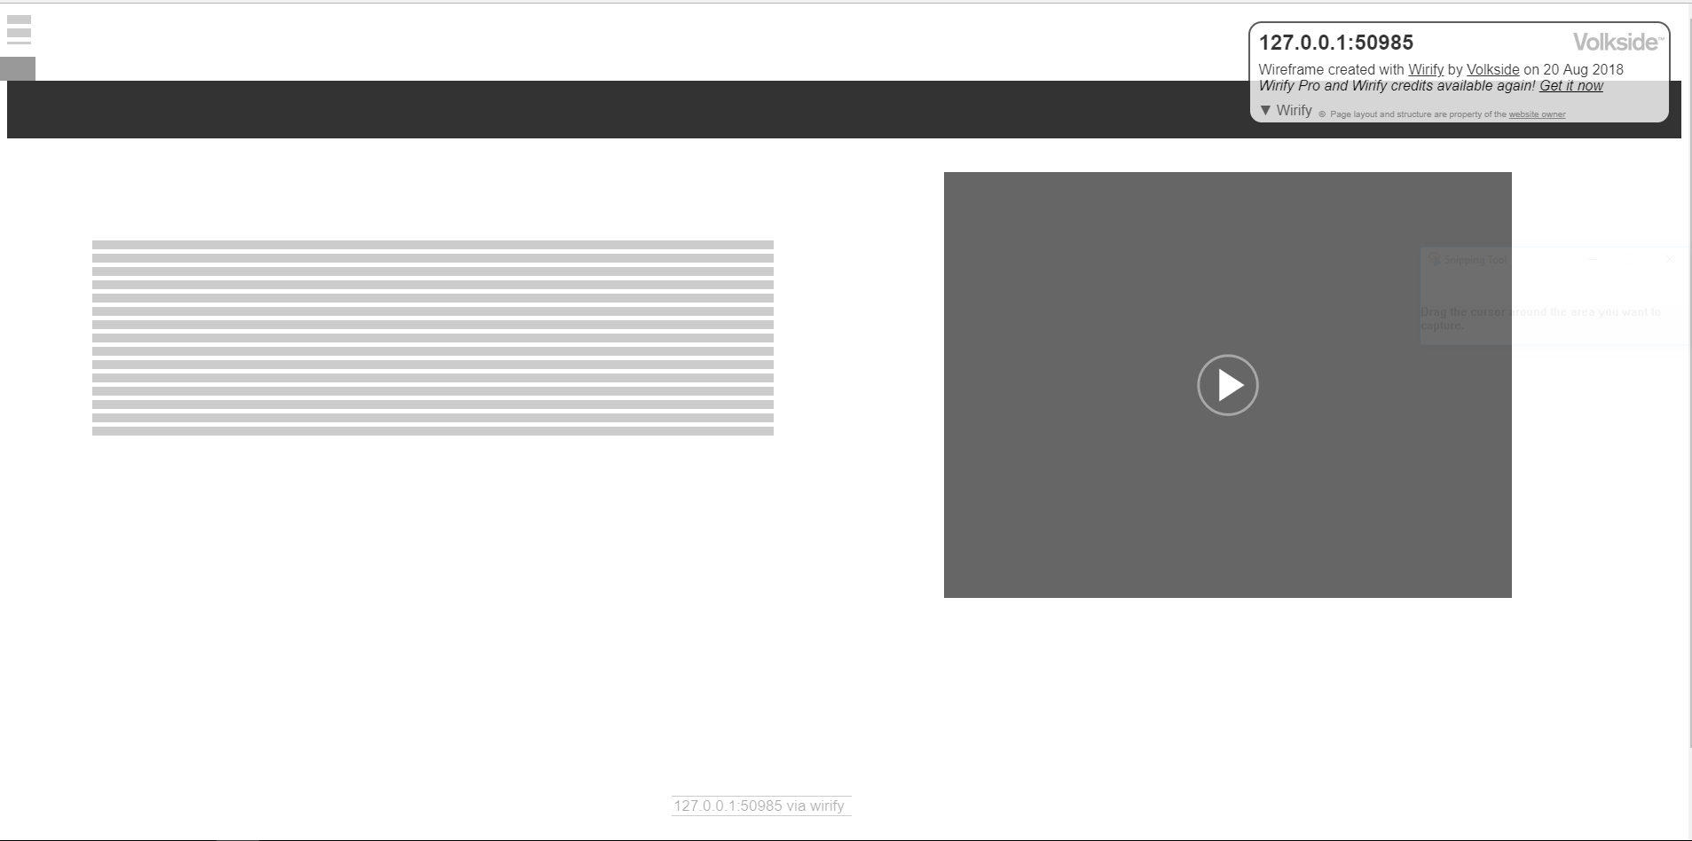

Tilt brush and My Model wireframe

* Thinking and selecting a colour theme (possibly based on research) Colour pallet acquired from coolors.

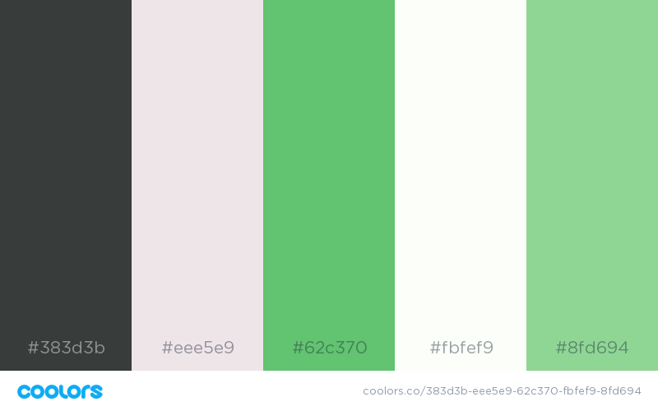

* What content and where? For most of my pages I put the title at the top centre of the page. I had text on the left and some sort of photo or 3D model on the right. For my home page I had three 3D models. One central and two others either side at a slightly smaller size.
* Plan your navigation – how does it look like (inspiration) My navigation bar appears when you click on an icon in the top left of the screen. It comes out from the side of the screen and is slightly transparent. There is a drop-down bar on the navigation bar as well as a main button.
* Plan your assets (do you need to use someone else’s 3D object to add to your web pages) I am using two other models from students in my class and I have received their permission.
* Folder management

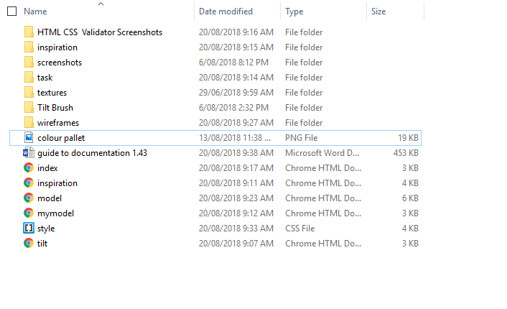

1. EVIDENCE OF MAKING THE WEBSITE

* What tools are you using? I am using Brackets in order to write my code. Brackets is a software which allows you to write HTML CSS and Java Script in a simple and easy way.
* Names of your pages? Home, Model Inspiration, Tilt Brush, Development Process and My Model.
* Techniques? (snapshots of code: i.e. how to set up a particular layout on a page)

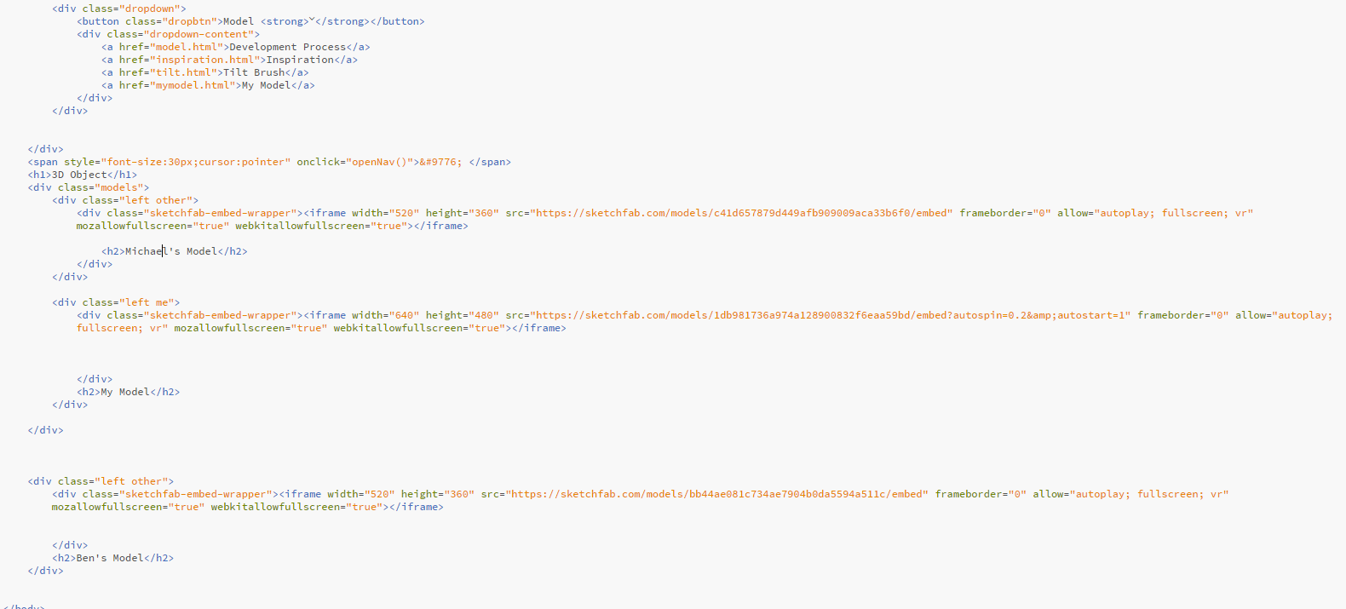

Part of Home Page code. This contains the code for the three models displayed on my home page.

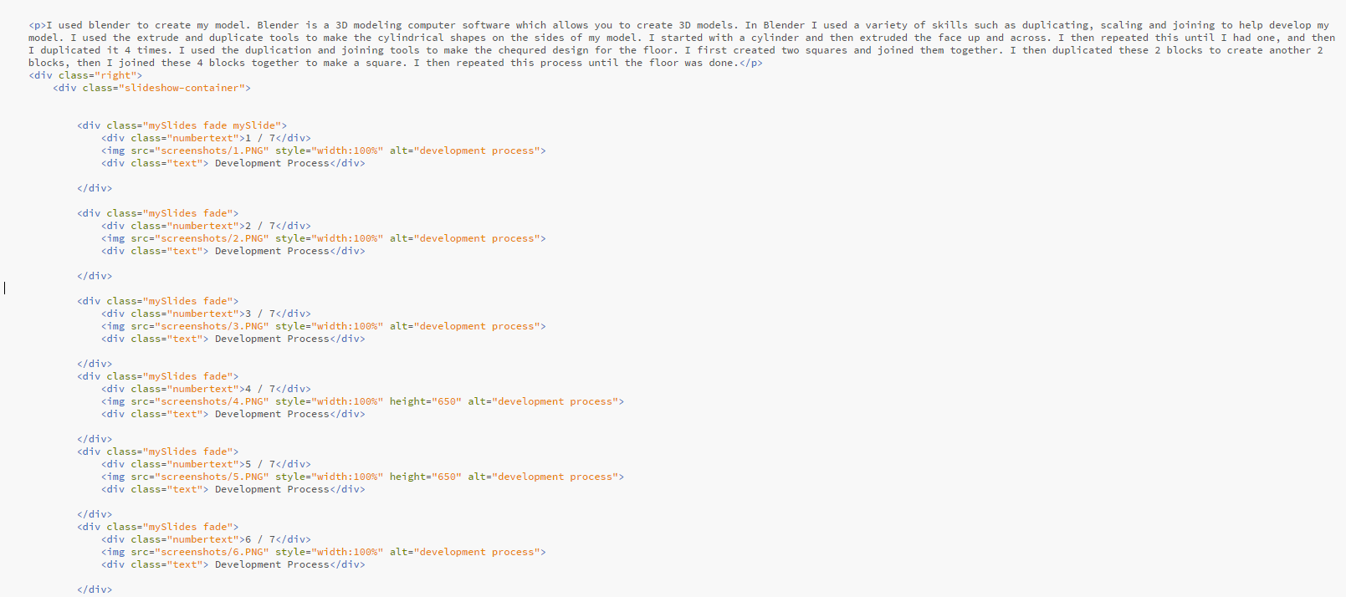

Part of Development Process page code. Here is some of the code for my slideshow. Each image is in the same div class as well as their own individual div. The div contains the code that makes the slideshow work.

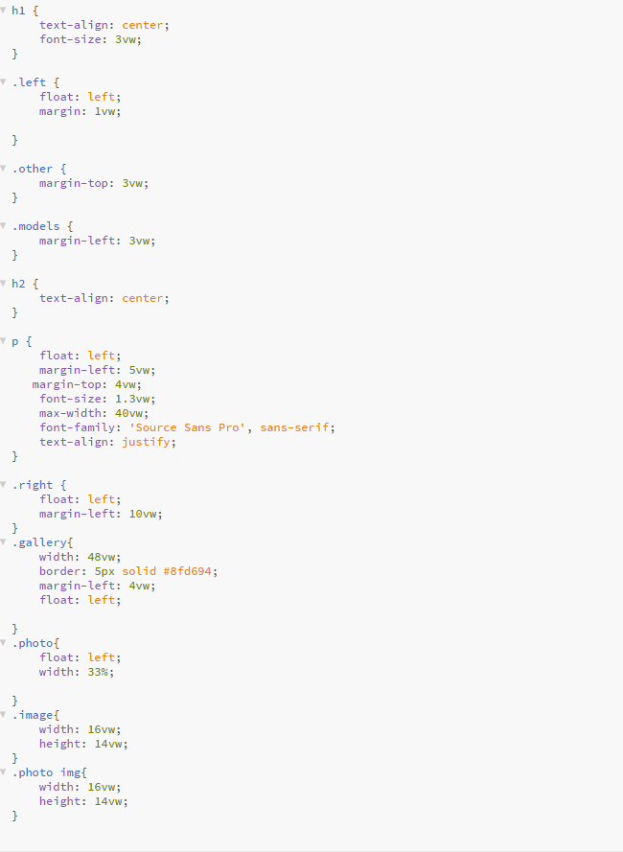

Part of CSS. Here you can see the CSS code for my paragraphs (p) this made my paragraphs sit on the left side of the page with a specific width, height, font size and position.

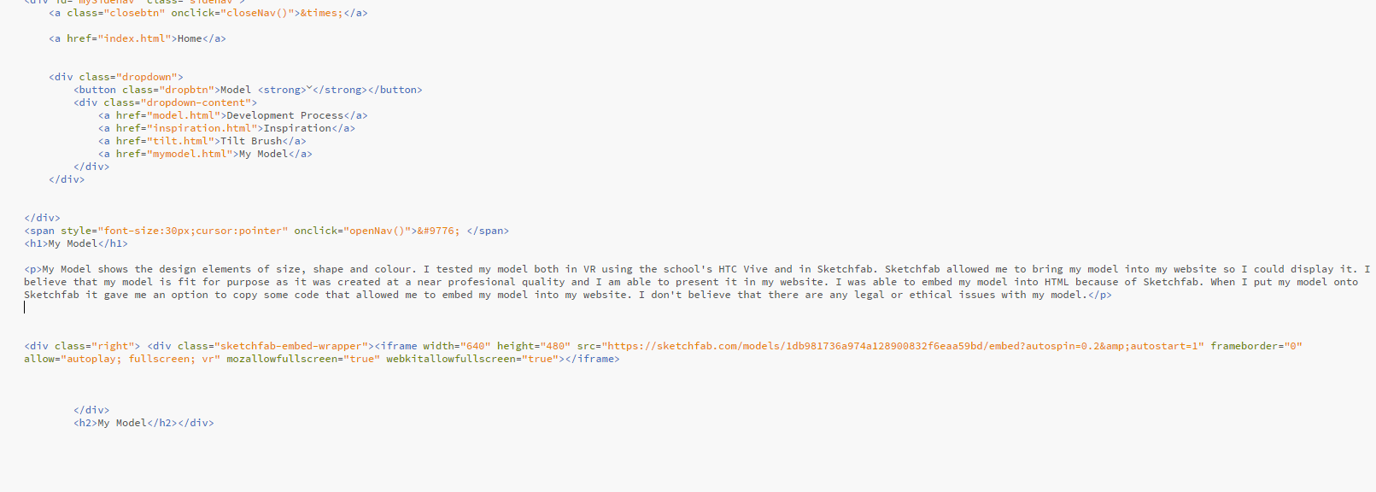

Part of My Model page. This shows the paragraph that I wrote for the My Model page as well as the code for the model.

* Testing HTML and CSS Validator (All these images are in a folder)

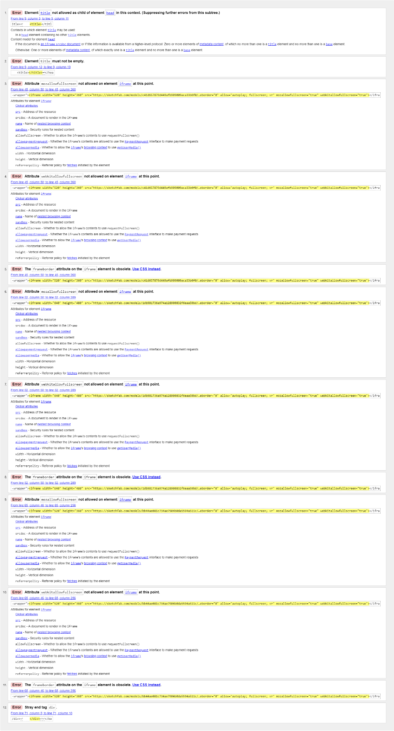

Home before fixing

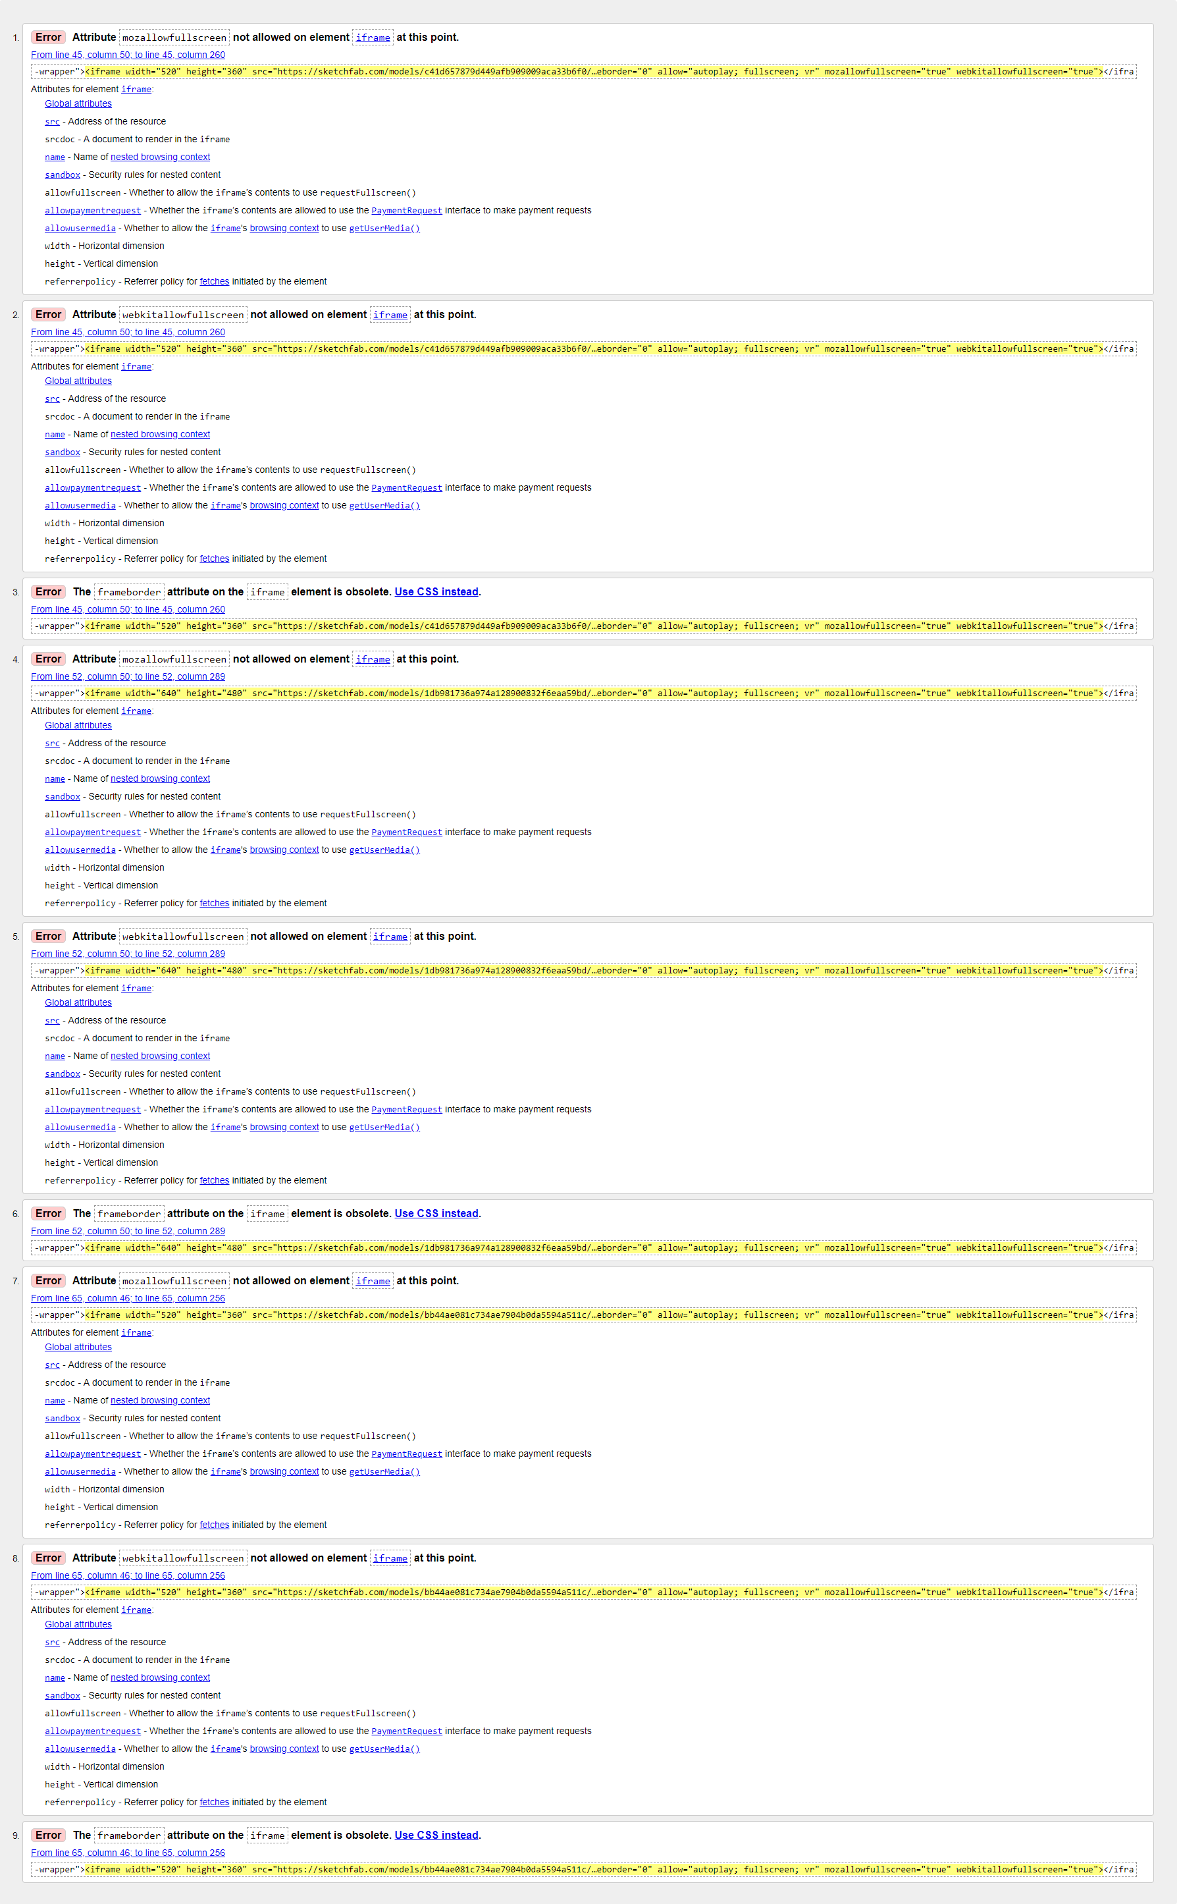

Home after debugging. Most of the errors are from the Sketchfab code for my models.

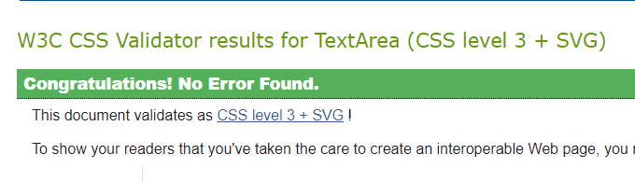

CSS code before debugging. It has no errors.

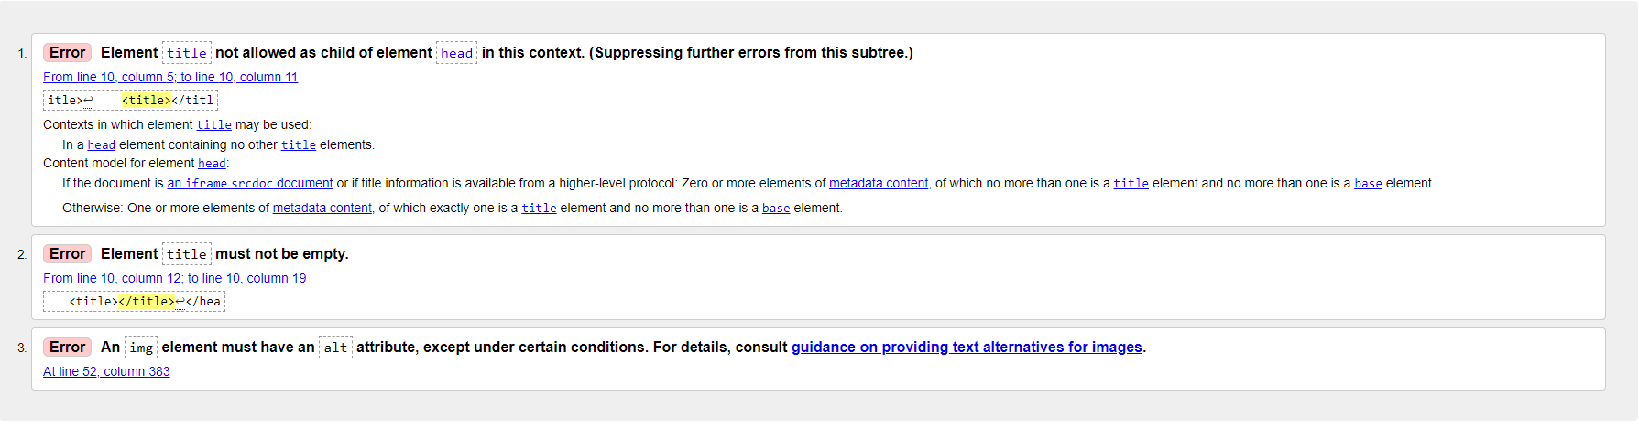

Inspiration Page before debugging.

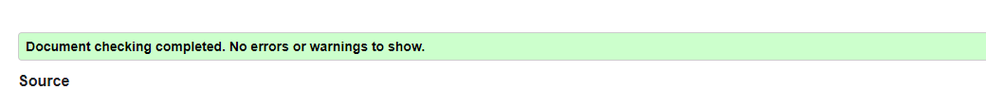

Inspiration Page after debugging all errors removed.

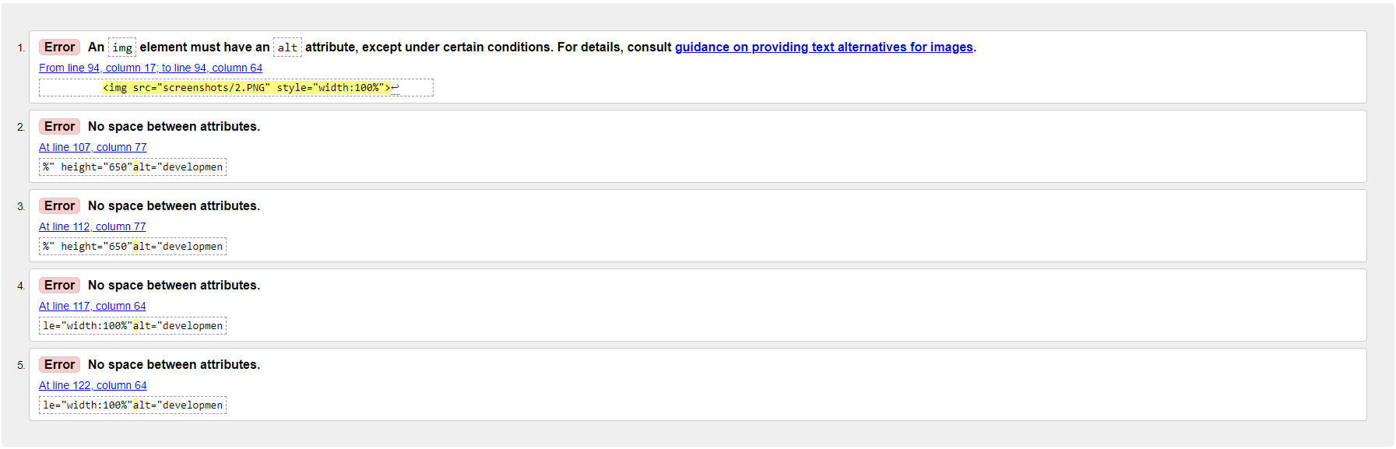

Development Process page before



Development Process page after debugging

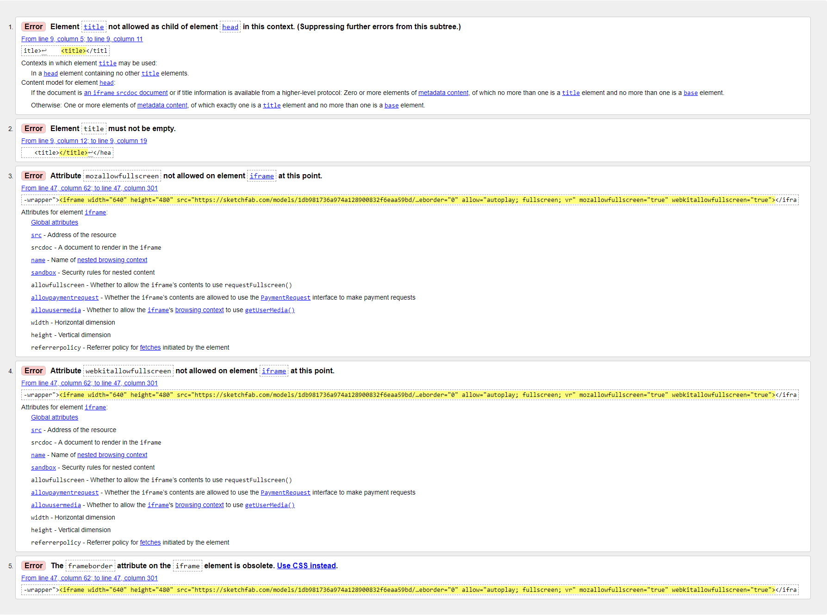

My model page before debugging

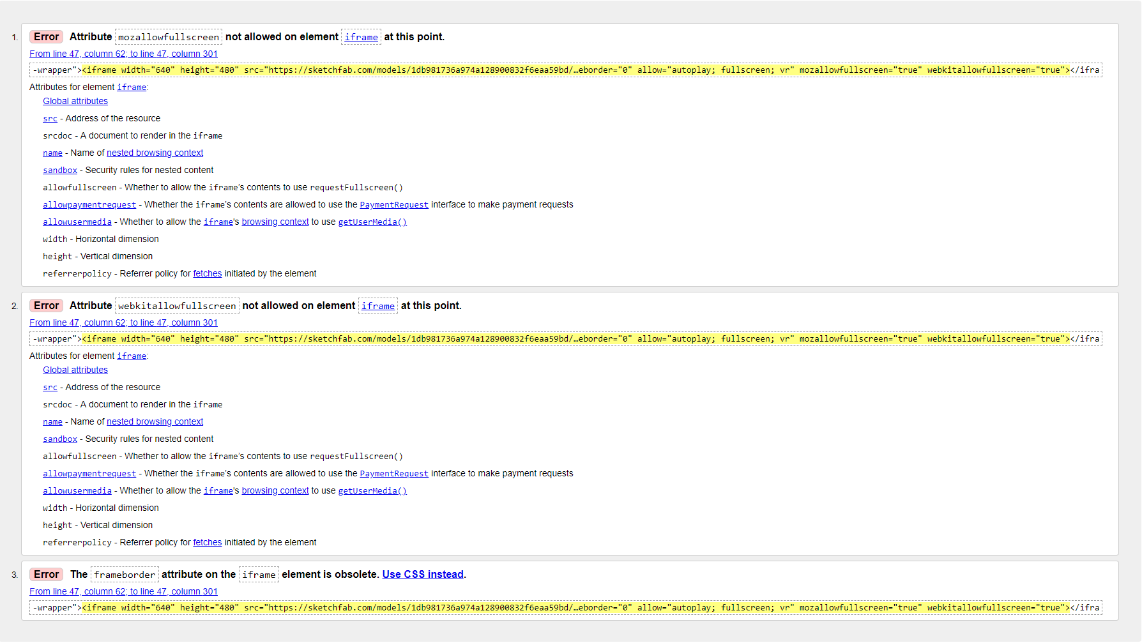

My model page after debugging

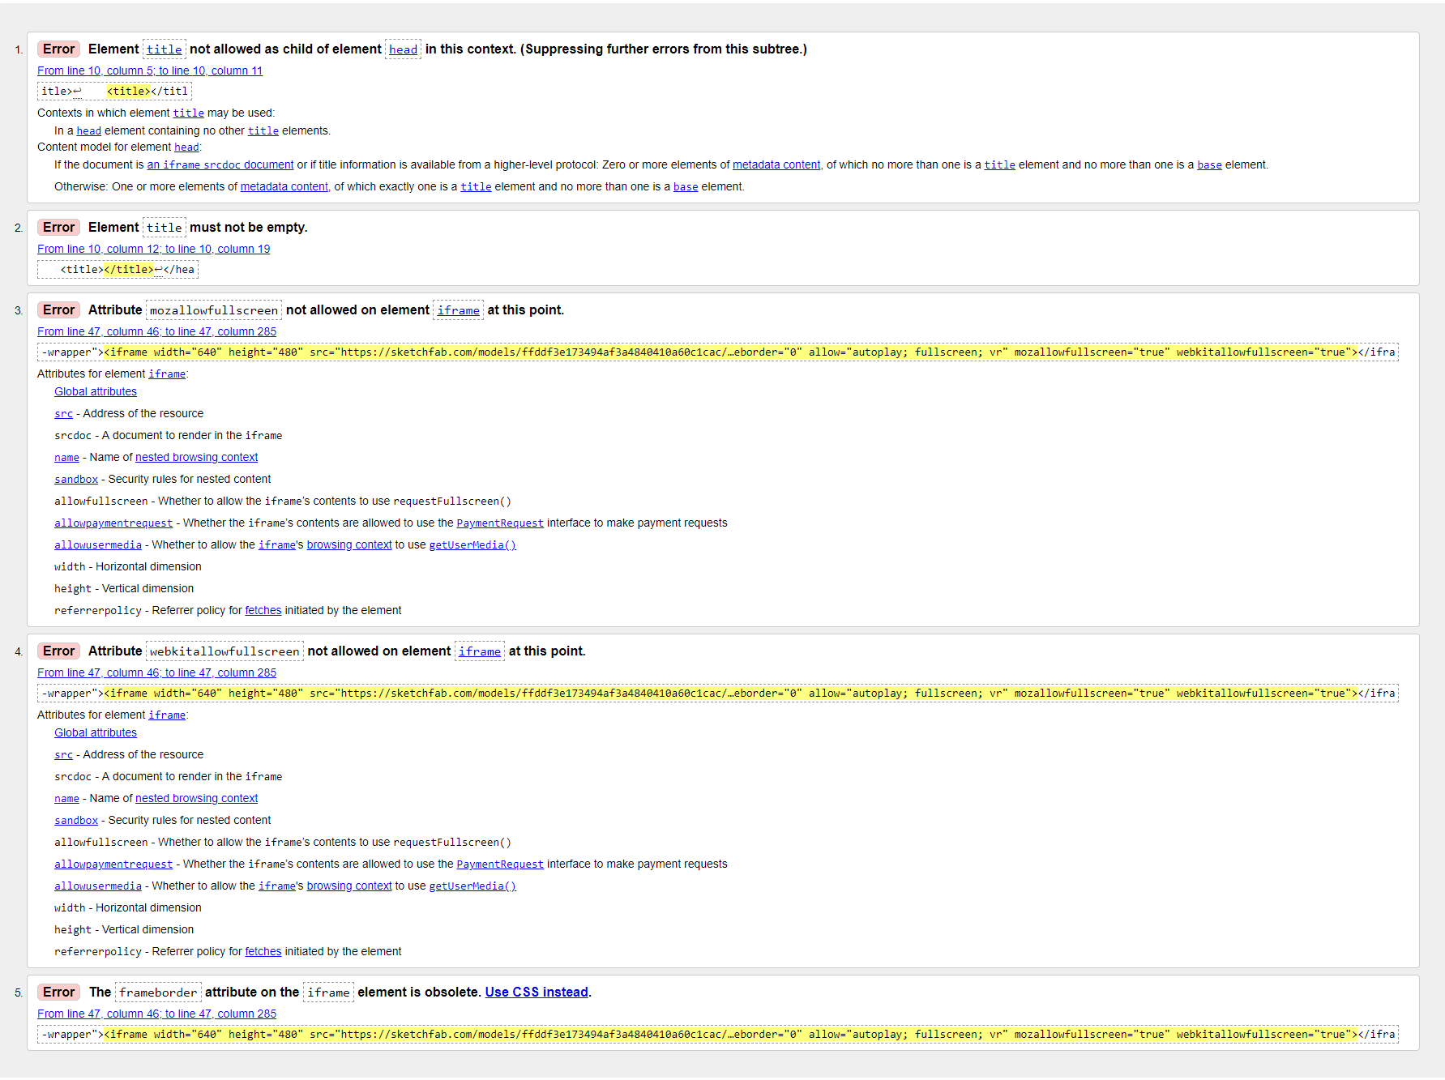

Tilt Brush page before

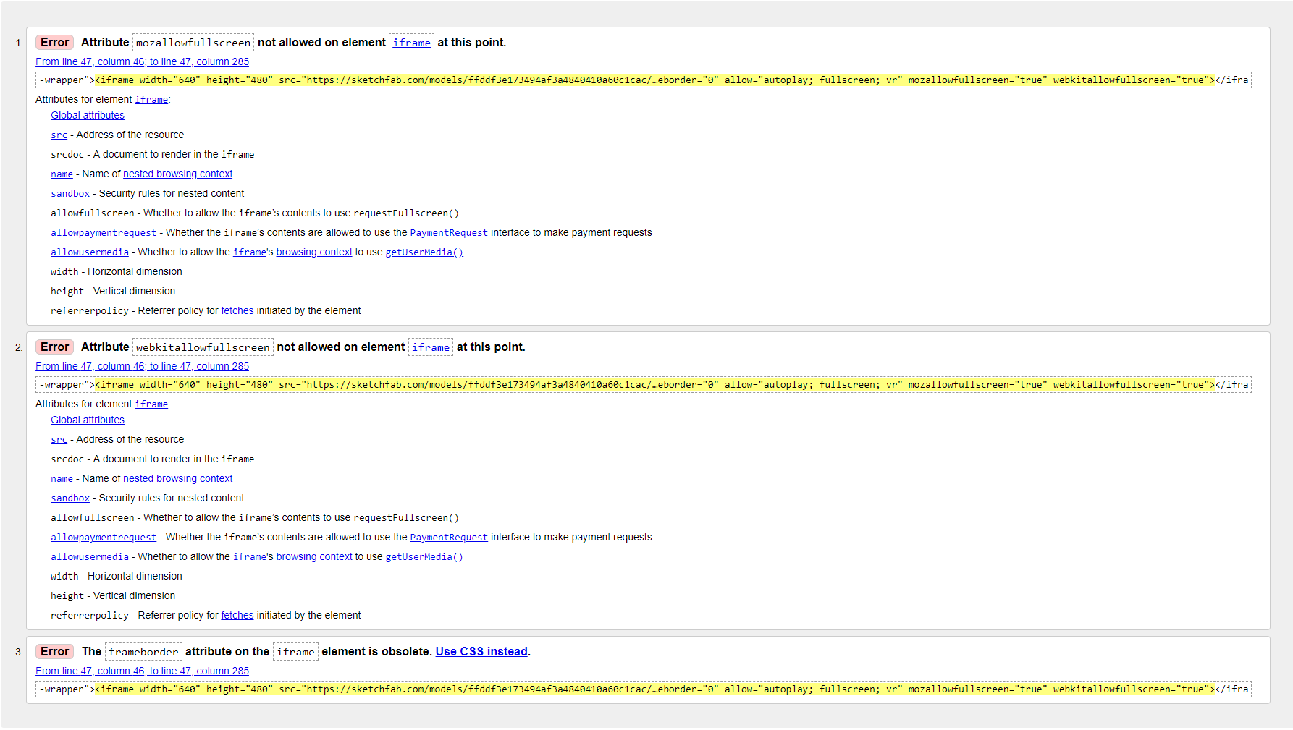

Tilt Brush Page after

* Testing
* Testing & Debugging
* Any feedback on your website?

“Work on your evidence, and if any time available, the layout of your pages - refining the position of the elements on your pages. You have done some really good work with your models and website to date. Make the Tilt Brush model a bit larger as relative to the page”

* Evaluate what you have accomplished with your final website

1. FINAL SUBMISSION

* MAKE SURE YOU HAVE SUBMITTED ALL OF THE EVIDENCE BY THE DEADLINE.